地点:广州塔
地址: 广州市海珠区阅江西路222号
地铁: 地铁3号线或APM线，广州塔站出口。
公交车：
262路、468路、旅游观光1线：广州塔西
204路、121路、121A路、旅游观光2线：珠江帝景苑总站

商家入场布展时间
Exhibitors booth build-up

11月16日15：00pm开始
From 16th Nov 15:00PM onward

车辆在北斜坡入口进入
Delivery vehicles can enter the premise from the north slope entrance.

工作人员在东楼梯进入
Exhibitors can enter the premise using the East stairwell.

1. 16日进入的人员和车辆须是已提交资料的车辆及人员，如有变动的，请提前通知进行协调后，允许进入的再进入到相关区域，以免堵塞及阻碍其他商家进场。
Only personnel and vehicles with prior entry permit applications will be allowed entrance. Please notify us of any changes. In order to avoid the traffic jam, please make confirmation before you get into the premise.

2. 工作人员须凭身份证及活动证件进入。活动证件会在东楼梯由GIVES义工派发。因16日义工人员有限，没有办法坐点在东楼梯等候商家到场，请务必提前15分钟通知义工取证。
Entrance will be granted only with personal identification (Chinese ID card or passport), together with Exhibitor Pass. GIVES volunteer will issue the Exhibitor Pass on the East stairwell. Due to limited GIVES volunteer on the day, please inform GIVES volunteer 15 minutes before your arrival, and GIVES volunteer can meet you at the East stairwell.

3. 活动证件需保存好，在进场后或者离场前须交给GIVES义工统一收回。
Please keep the exhibitor Pass properly, and the pass must be returned to GIVES upon exit.

4. 平台放行车辆有数量限制，每次只通行两辆，请大家错峰进入并耐心等候车辆放行。
Only two delivery vehicles will be allowed to enter each time. We advise having delivery vehicles arrived in different hours to minimize queue.

5. 因二楼平台的地砖为特制地砖，较为脆弱，卸货时请注意不要随意抛扔物品，如造成地面或其他设施设备损坏，或其他商家损失的，需自行承担赔偿及其他相关责任。
Due to the fragile nature of the flooring on the 2nd floor platform, please be careful during unloading. The offender will be liable for any damages caused, including monetary compensation and/ or other relevant liabilities.

6. 已完成卸货工作的车辆须尽快离开二楼平台，以便其他车辆可以进入。
For delivery vehicle, please leave the 2nd floor platform ASAP after unloading.

5. 入场的工作人员只允许在二楼平台进行布展工作，严禁进入广州塔内。
Exhibitors are only allowed to be on the 2nd floor platform for exhibition arrangement, and strictly no entrance to the Canton Tower.

6. 工作人员不能在二楼平台滞留，布展完毕后须迅速离开。
Staff should leave immediately after the completion of the exhibition arrangement. No loitering or staying allowed.

7. 因现场会有多家商家及搭建供应商在平台进行搭建布展工作，各商家需注意安全生产，确保人员及财物的安全。
Due to the huge number of exhibitors, please pay attention to your personal and property safety during exhibition arrangement.

11月17日9点半
9:30 AM 17th Nov

车辆在北车道卸货区域停车卸货，然后推行到西楼梯入场，在活动结束前，车辆不能驶入二楼平台。
Unloading is only permitted at the north lane unloading area. Goods should be then delivered to the exhibition via handcart, enter via the west stairwell. No vehicle will be allowed on the 2nd floor platform during the carnival.

工作人员可以在西楼梯或者东楼梯进入
Exhibitors can enter from the East or West stairwell.

1. 上午9点半在西广场扶手梯售票处领取商家摊位证，每个摊位4张商家证。
Each booth will be given 4 vendor passes. Passes should be obtained at 9:30AM, at the West Square ticket office, next to the escalator.

2. 上午9点半前不允许入场，9点半后可凭商家摊位证在西广场扶手梯及楼梯进场。
No entrance permitted before 9:30AM. Entry will be granted for personnel with vendor pass via west square escalator and stairwell.

3. 上午9点半至下午2点期间，从西广场入场后不可以使用手推车，如有物品，须经过安检后进入。
Handcarts are forbidden from 9:30 am to 2:00 pm in the carnival. Anything material to be brought into event should be hand carry and pass through security gate and scanning.

4. 活动期间注意场地卫生与安全，产生的污水、废油应在退场时带离现场。不能将油污溅到地上，不能随意倾倒污水，如有发现将会要求商家清洗或缴交清洁费用。
Please keep the site clean and safe. Garbage and dirty water should be taken way when evacuating the event site. Do not litter oil, dirty water or other waste on the ground. The offender will have to clean up or pay for cleaning.

5. 商家退场必须有经过审批的放行条，没有放行条的物品不能离场。
For removal, items can only evacuate from the event site with approved release notes. Exhibitor without release note will not be allowed to remove item from the event site

6. 义工工作人员会在活动开始后派发放行条，请妥善保管并尽快填妥，工作人员在下午3点统一收取送审，并在活动结束前派发给各个商家。
Volunteers will be handing out release notes after the event started. Please keep the note carefully and fill in the necessary information. Volunteers will collect all release notes for approval at 3:00pm, and will return the approved release notes before the end of the event.

7. 撤场时如需要车辆进入二楼平台的，需在活动结束23：00后进入。车辆须是已经提交登记车牌号码的车辆，未登记车辆不予放行。无需车辆进场的商家可以使用手推车将物品推行通过卸货通道离场。
Only registered vehicles can only enter 2nd floor platform after 23:00. There will be no on-site vehicle registration. Booth holders who do not need vehicles can remove items from the site using handcarts.

8. 撤场离场需出示放行条，请确认放行条已有相关部门的签名确认
Please ensure your release note is signed by the appropriate department, and no removal will be allowed without the approved release note.

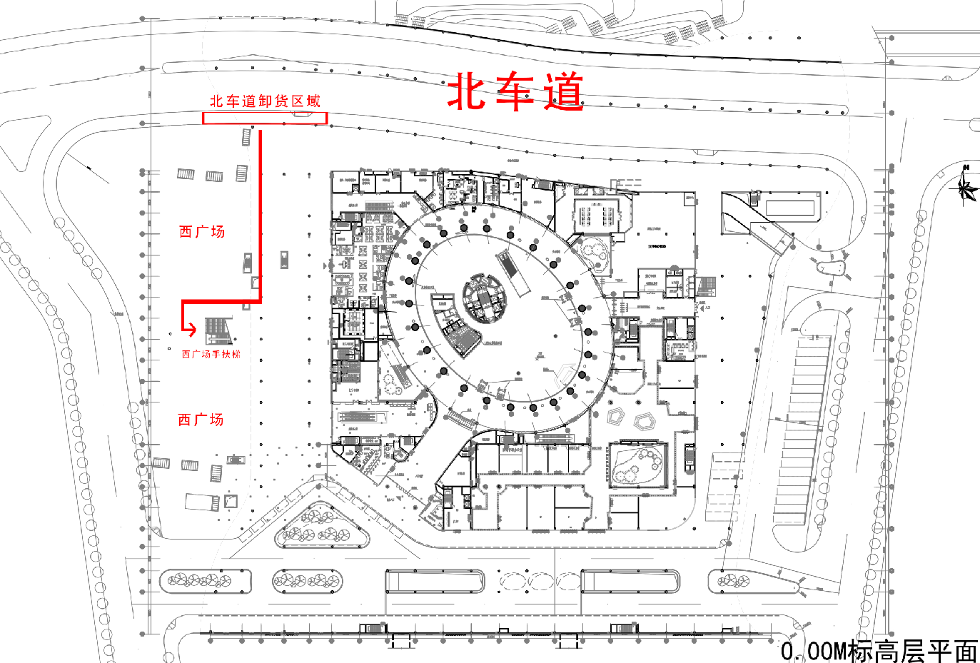

表演团体入场安排：
Performance group entrance arrangements:

1.活动当天提前与表演管理义工电话联系，在西广场手扶梯入口处等候义工派发入场证，凭已经登记的身份证件领取入场门票进入会场。
On the day of the event, please contact the performance management volunteers in advance for admission pass. The pass will be given by the west square escalator area, and please have your identification (PRC ID card or passport) ready for pass issuance.

2.表演者入场后请在表演者报到处报到，并提交音乐等表演材料。
Performers please register at the sound/ performer’s check-in booth and submit performing material, such as music sheet.

3. 如有带备大件乐器的或者表演器材的，请入场后尽快填写放行条并联系义工提前办理放行条。如能手提的乐器可手提离场。
Performers with large musical instrument or performance equipment, please fill in the release note as soon as possible after entering the venue, and contact GIVES volunteer to apply for the release note in advance, to facilitate a smooth exit. For portable items, no release note is necessary for removal.

