B/E/F Gas Turbine Single/Combined cycle performance Optimization

The gas turbine units in many regions are operating at partial load with many hours in a year. Most time the power plants do not take any action to optimize performance. Actually, there are always some solutions to improve output or efficiency to these power plants so that the plants may earn more profit or save fuel cost in a significant extent in a year.

Gas & Aero Power can provide many solutions in performance optimization, such as IGV optimization, Part load efficiency (PLE), Inlet chilling system, etc.

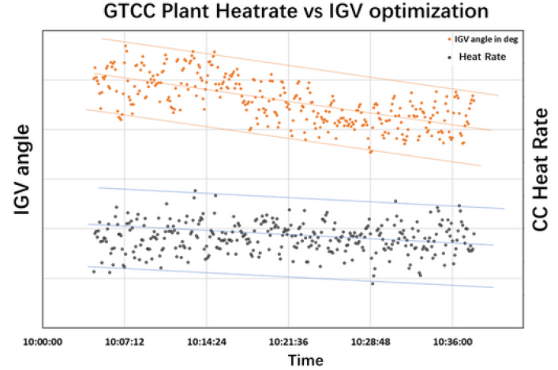

By modify IGV opening in part load, CC heat rate can reduce by 0.2%

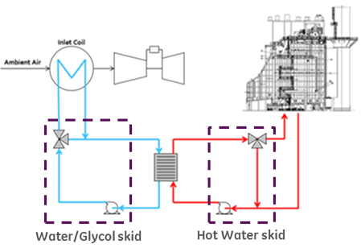

By applying inlet heating system, CC part load efficiency can improve 1% or above