EU Declaration of Conformity (DOC) for Carbon Zinc-Manganese Dioxide R03P Battery

EU Declaration of Conformity

Regulation (EU) 2023/1542

Manufacturer: Shenzhen Deanda Technology Co., Ltd.

Document No.：DAD-EUDOC-R03P-20260418

1. Product Information

Product: Carbon Zinc-Manganese Dioxide R03P Battery (Non-rechargeable)
Battery Category: Portable battery, Model: AAA R03P
Batch Number: Traceable via purchase order number, packaging label, or by subtracting 3 years from the expiry year printed on the battery.

2. Scope of this Declaration

This declaration covers the below listed product:

Carbon Zinc-Manganese Dioxide Battery (Non-rechargeable)

- Model: AAA R03P
- Electrochemical System: Zinc-Manganese Dioxide
- Nominal Voltage: 1.5 V
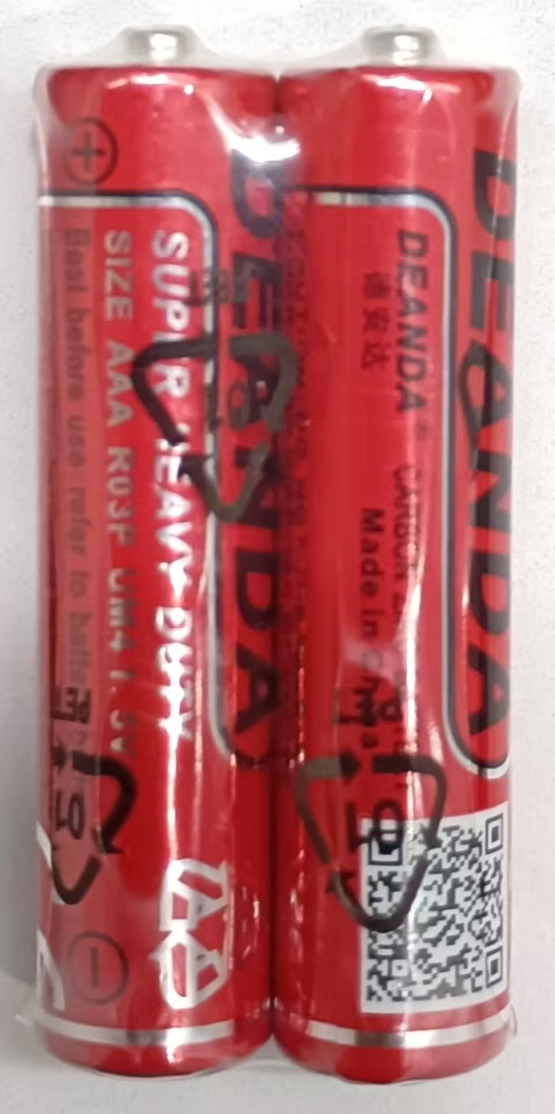
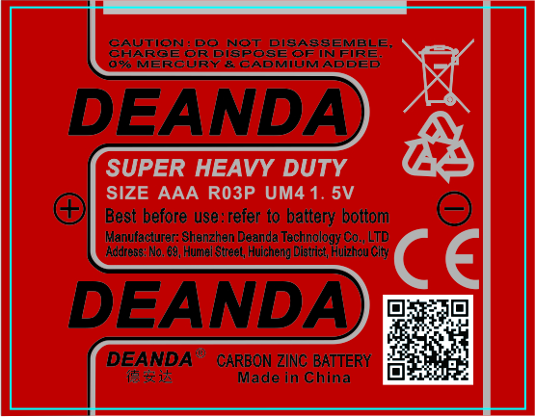
- Nominal Capacity: 400 mAh
- Category: Portable battery (sealed, ≤ 5 kg)
- Battery Type: Primary (Non-rechargeable) battery

The battery can be identified by the model marking AAA R03P printed on each battery cell and product packaging. Batch numbers can be traced by subtracting 3 years from the expiry year marked on the battery, or via purchase order numbers and packaging labels.

For full technical specifications, performance data, markings and safety information, please refer to the battery information sheet.
(DEANDA brand label schematic diagram attached)

3. Manufacturer

Manufacturer Name: Shenzhen Deanda Technology Co., Ltd.
Address: No. 69 Humei Street, Dashuling, Xiaojinkou, Huicheng District, Huizhou City, Guangdong Province, China
Postal Code: 516023
Website: www.szdeanda.com
E‑mail: xiajh@desaypow.com

4. EU Authorised Representative

Representative: Apex CE Specialists GmbH
Address: Grafenberger Allee 277, 40237 Düsseldorf, DE
Contact Person: Wells Yan
E-mail: Info@apex-ce.com
Telephone: +49 21312066043

5. Declaration of Conformity

We, Shenzhen Deanda Technology Co., Ltd., take full responsibility and declare that the above mentioned product satisfies the applicable requirements of:

Regulation (EU) 2023/1542 of the European Parliament and of the Council of 12 July 2023 on batteries and waste batteries, amending Directive 2008/98/EC and Regulation (EU) 2019/1020, and repealing Directive 2006/66/EC.

Conformity has been assessed by verifying compliance with the technical specifications, standards and regulations listed below.

6. Applicable Standards

1. IEC 60086‑1:2021
Primary batteries – Part 1: General
2. IEC 60086‑2:2021
Primary batteries – Part 2: Physical and electrical specifications
3. IEC 60086‑5:2021
Primary batteries – Part 5: Safety requirements for batteries with aqueous electrolytes

7. Conformity Assessment

Assessment Procedure: Module A — Internal Production Control

The conformity assessment procedure applied is Module A — Internal Production Control, as described in Annex VIII of Regulation (EU) 2023/1542. Under this procedure, the manufacturer bears full responsibility for ensuring the battery complies with all applicable regulatory requirements. The manufacturer shall retain the technical documentation and this EU Declaration of Conformity for 10 years for inspection by national regulatory authorities.

Notified Body: Not applicable
Not applicable — Module A (Internal Production Control) does not require involvement of a notified body.

8. Restriction of Hazardous Substances Compliance

Hazardous‑Substance Compliance Statement

This product complies with the heavy metal concentration limits specified in Annex I of Regulation (EU) 2023/1542:

- Mercury (Hg): ≤ 0.0005 % by weight
- Cadmium (Cd): ≤ 0.002 % by weight (portable batteries only)
- Lead (Pb): ≤ 0.01 % by weight

This product complies with applicable restrictions under REACH Regulation (EC) 1907/2006 Annex XVII.
This product complies with EU POPs Regulation (EU) 2019/1021.

Testing was performed in accordance with the IEC 62321 series of standards.
This product contains no substances listed on the REACH Candidate List of Substances of Very High Concern (SVHC) above 0.1 % by weight.

For the full hazardous substance statement, please refer to the Hazardous Substances section of the battery information sheet.

9. Other Regulatory Provisions

Article 7 — Carbon footprint declaration: Not yet applicable
The delegated act establishing carbon footprint calculation rules for portable batteries has not yet been issued under Regulation (EU) 2023/1542. This requirement is currently not enforceable for this battery category.

Article 8 — Recycled material content in batteries: Not yet applicable
The delegated act setting minimum percentage thresholds for recycled material content in portable batteries has not yet been issued. This requirement is currently not enforceable for this battery category.

Article 11 — Removability and replaceability of portable batteries: Not yet applicable
This zinc manganese dioxide battery is supplied as a standalone product and is not pre installed into any equipment by the manufacturer. The removability and replaceability obligations under Article 11 apply only to portable batteries fitted within equipment and are therefore not applicable to this product.

Articles 48-52 — Supply chain due diligence obligations: Not yet applicable
The due diligence obligations set out in Chapter VII of the Regulation apply only to economic operators with an annual net turnover exceeding EUR 40 million. Shenzhen Deanda Technology Co., Ltd. does not meet this threshold at the date of issue of this declaration.

Annex III — Performance and durability requirements: Not yet applicable
The performance and durability requirements of Annex III for portable batteries shall apply from 18 August 2028. In addition, Annex III explicitly excludes button cells from electrochemical performance and durability requirements. For reference, the performance characteristics of this battery (capacity, minimum average service duration and application specific test results) are documented in the battery information sheet.

Directive 2014/30/EU — Electromagnetic Compatibility (EMC): Not applicable
This is a passive primary (non-rechargeable) zinc-manganese dioxide battery without any active electronic components, integrated circuits or battery management systems. Given the absence of internal electronic switches or signal processing hardware, EMC Directive 2014/30/EU does not apply to this product.

Battery Management System (BMS): Not applicable
This product is a passive primary (Non-rechargeable) zinc-manganese dioxide battery containing no electronic components, circuits, battery management systems or communication interfaces. Regulatory clauses and requirements concerning batteries fitted with a BMS or active electronics functionality do not apply to this product.

10. CE Marking and Labelling

The markings listed below are printed on the battery cell or embedded within QR code information, complying with Article 13 and Annex VI of Regulation (EU) 2023/1542:

- CE Mark: Indicates compliance with all applicable EU health, safety and environmental protection requirements (Articles 19-20).
- Separate collection symbol (crossed out wheeled bin): Complies with Article 13 and Annex VI Part B; indicates the battery must not be disposed of together with unsorted municipal household waste.
- Chemical symbols "Cd" and "Pb" (if limit values are exceeded): This model does not exceed the threshold limits; hence these symbols are not required.
- "Keep out of reach of children" symbol: Complies with Article 13; warns of ingestion hazards, especially for young children.
- "Non-rechargeable" symbol: Identifies this product as a primary (Non-rechargeable) battery; charging may cause leakage, fire or explosion.
- Model identifier "AAA R03P": Printed on the battery cell.
- Valid date code (month-year format): Printed on the battery cell.
- Nominal voltage (1.5 V): Printed on the battery cell.

Full details on markings and labelling can be found in the Markings section of the battery information sheet.

Sign-off

On behalf of:
Shenzhen Deanda Technology Co., Ltd.

Place: Huizhou, China Date: 18-04-2026
Name: Xia Junhui Title: Sales Director
(Signature)

On behalf of:
Apex CE Specialists GmbH

Place: Düsseldorf, Germany Date: 18-04-2026
Name: Wells Yan Title: Authorised Representative
(Signature)

Manufacturer Name: Shenzhen Deanda Technology Co., Ltd.
Address: No. 69 Humei Street, Dashuling, Xiaojinkou, Huicheng District, Huizhou City, Guangdong Province, China
Postal Code: 516023
Website: www.szdeanda.com
E‑mail: xiajh@desaypow.com

